EU SEED MARKETING LEGISLATION IMPACT ASSESSMENT SURVEY

WHAT?
The European Commission is looking to reform the European Union (EU) seed marketing legislation, with a proposal expected by December 2022.
To assess the policy options that they are studying right now, the EU Commission has launched a public consultation, which is open to associations and individuals in the EU, and anywhere around the world, until 27th March 2022.

HOW?
To respond to the survey, you need to create an ‘EU login’ (you only need an email address to do it, independent of your nationality or place of residence):
- Go to the EU login page by entering the following address in the browser: https://webgate.ec.europa.eu/cas/login
- Click “Create an account” & provide the information requested (first & last name, email address & language)
- Follow the link provided in the confirmation e-mail from EU login sent to the e-mail account provided in the registration form (valid for maximum 1,5 hours) & create your password

Link of the EU SEED MARKETING survey:
- IN ENGLISH: https://ec.europa.eu/eusurvey/runner/PRM-FRMSurvey2022?surveylanguage=en

You can fill in the questionnaire according to the suggestions made on the next page, and add the commentary prepared to explain the choices made, and further insist on the need to take into account of effects of the EU reform in terms of Policy Coherence for Development.

- Questionnaire
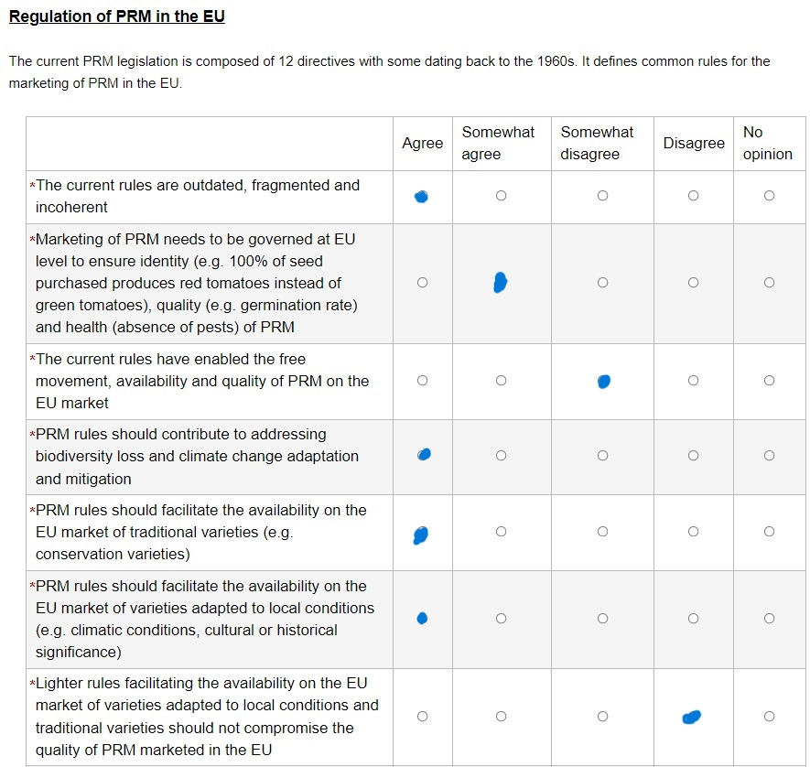
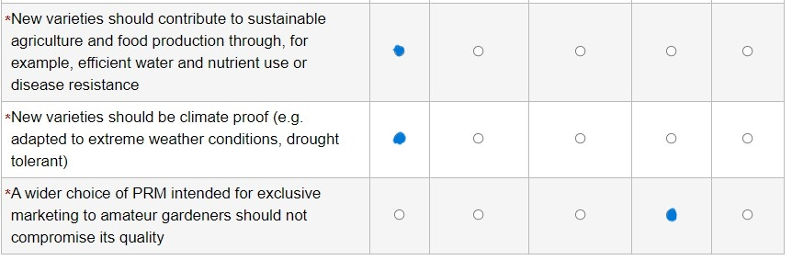
- Additional commentary (maximum 500 characters)
PCD (TFEU Art 208, 21) obligations imply the future reform upholds obligations under UNDROP (Art 19) and ITPGRFA (Art 9), excluding farmer/peasant seed systems from the scope of seed marketing. Farmers/peasants must have access to locally adapted quality seeds, under a proportionate stand-alone legal regime. Any new varieties must contribute to sustainability and biodiversity, evaluated through the cultivation system. A transparency system must ensure farmers can make a truly informed choice.

